**EXPERIMENT NO.5**

**BY- Gatik Veer**

**Roll N.o. - 2110990493**

**AIM:** Git life cycle

Git is used in our day-to-day work, we use Git for keeping a track of our files, working in a collaboration with our team, to go back to our previous code versions if we face some error. Git helps us in many ways. Let us look at the Lifecycle description that git has and understand more about its life cycle. Let us see some of the basic steps that we have to follow while working with Git :

* You clone the Git repository as a working copy.
* You modify the working copy by adding/editing files.
* If necessary, you also update the working copy by taking other developer's changes.
* You review the changes before commit.
* You commit changes. If everything is fine, then you push the changes to the repository.
* After committing, if you realize something is wrong, then you correct the last commit and push the changes to the repository.

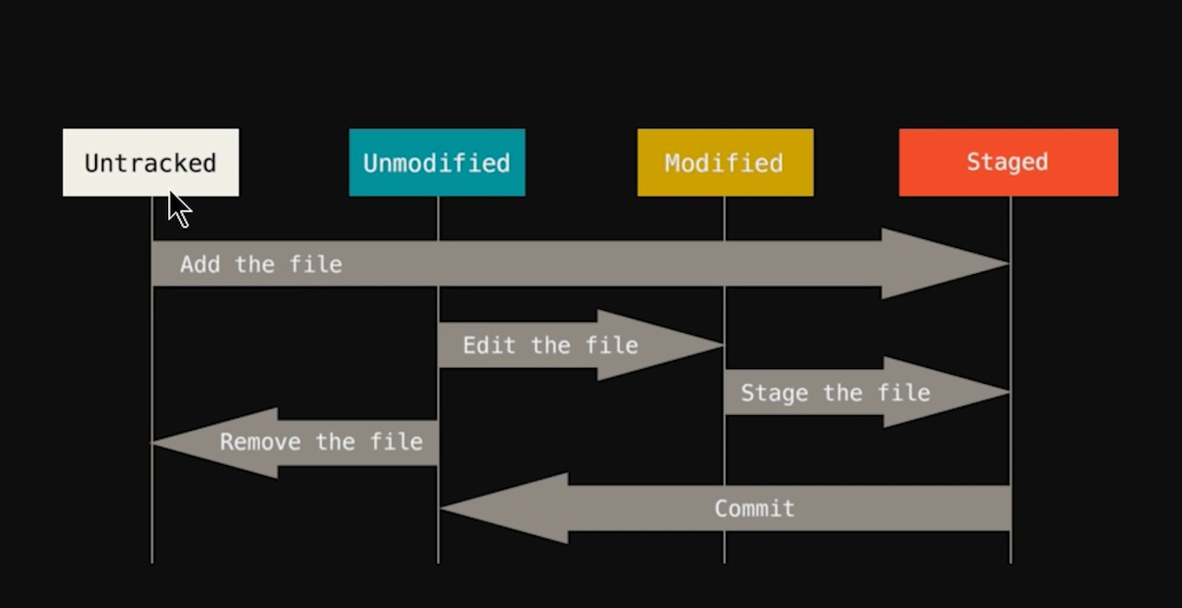

* **WORKING DIRECTORY**

This is where you work with your files as you are updating them. This is on your local machine.

* **STAGING AREA**

Now, to track the different versions of our files we use the command ***git add***. We can term a staging area as a place where different versions of our files are stored. ***git add*** command copies the version of your file from your working directory to the staging area.

* **GIT DIRECTORY**

Now since we have all the files that are to be tracked and are ready in the staging area, we are ready to commit our files using the ***git commit***command. Commit helps us in keeping the track of the metadata of the files in our staging area. We specify every commit with a message which tells what the commit is about.

